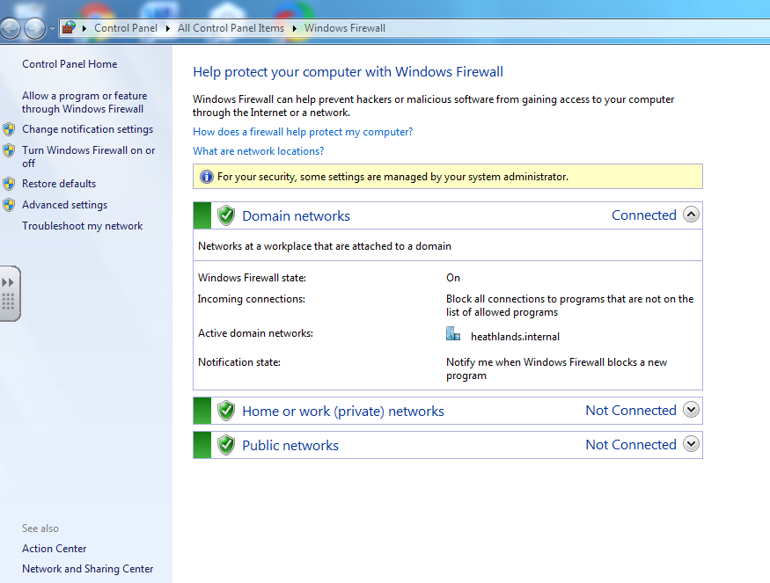

**How to turn Windows Firewall settings ON**

1. If it says OFF, click here and change it to ON
2. Check it says ON
3. Choose “Windows Firewall”
4. Go to “control panel” from the Start menu.